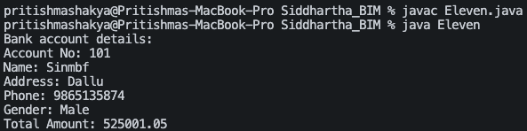

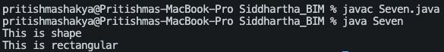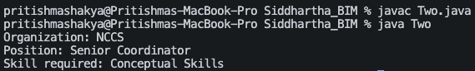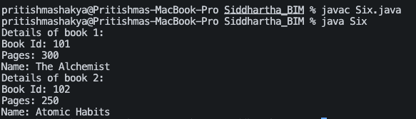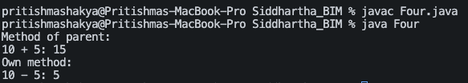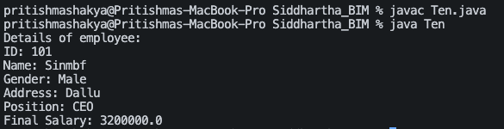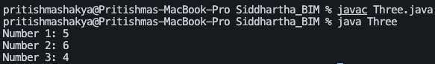National College of Computer Studies

Paknajol, Kathmandu

Lab Report On Object Oriented Programming With Java

Assignment No. 7

Inheritance

Submitted by: Submitted to:

Name: Siddhartha Shakya Mr. Sujesh Manandhar

Program: BIM  Mr. Kapil Chhatkuli

Section: B

Roll no: 23

Date of Submission: 2024/08/12

